AWS – Deploy wordpress with Amazone RDS

LAB -1: Creating a MYSQL Database with RDS

Go to Amazone RDS in the AWS console. Click the create database button to get started.

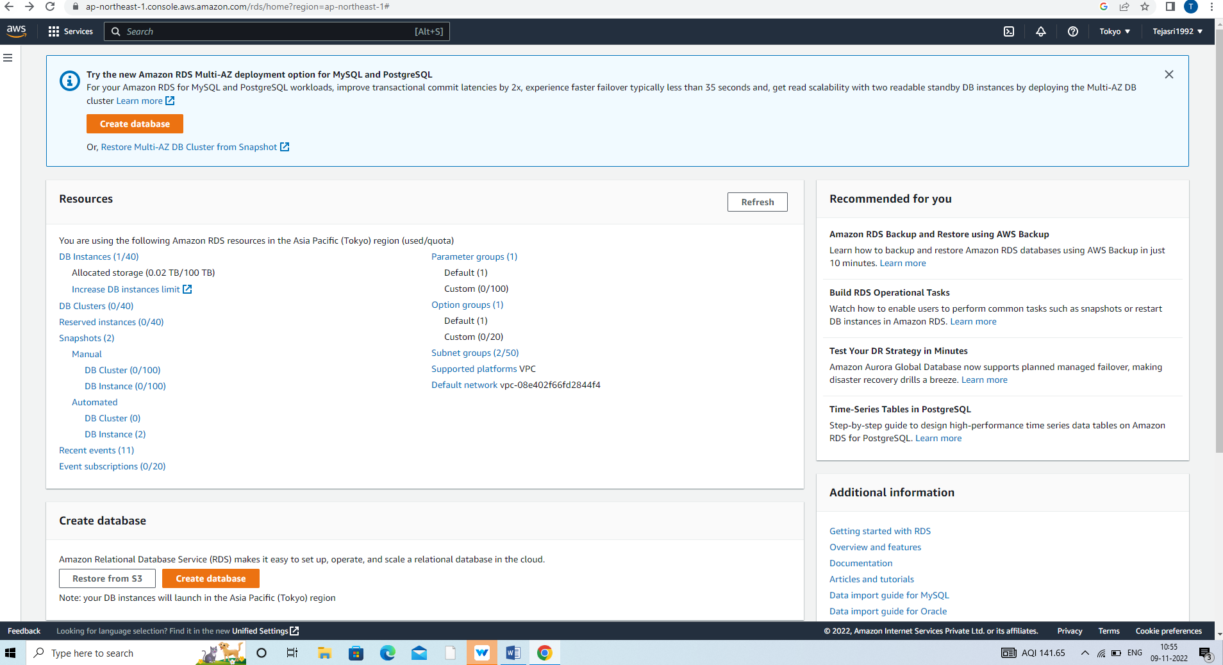

The first step is to choose the database engine you want to use. Wordpress uses MYSQL, selecte the engine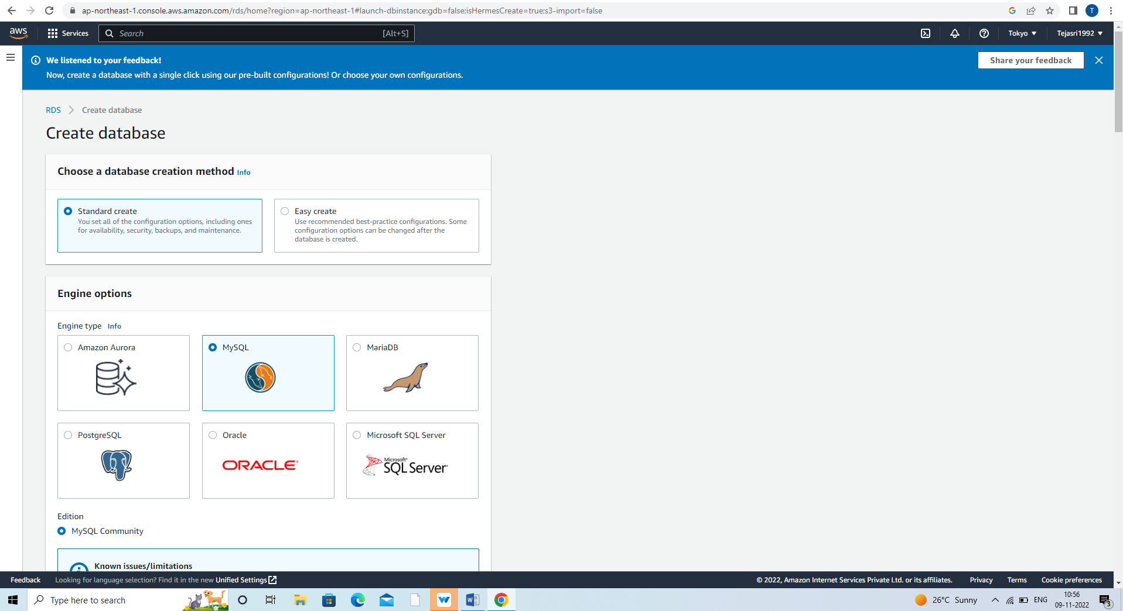

In the Template section of the AWS free Tier selecte the option

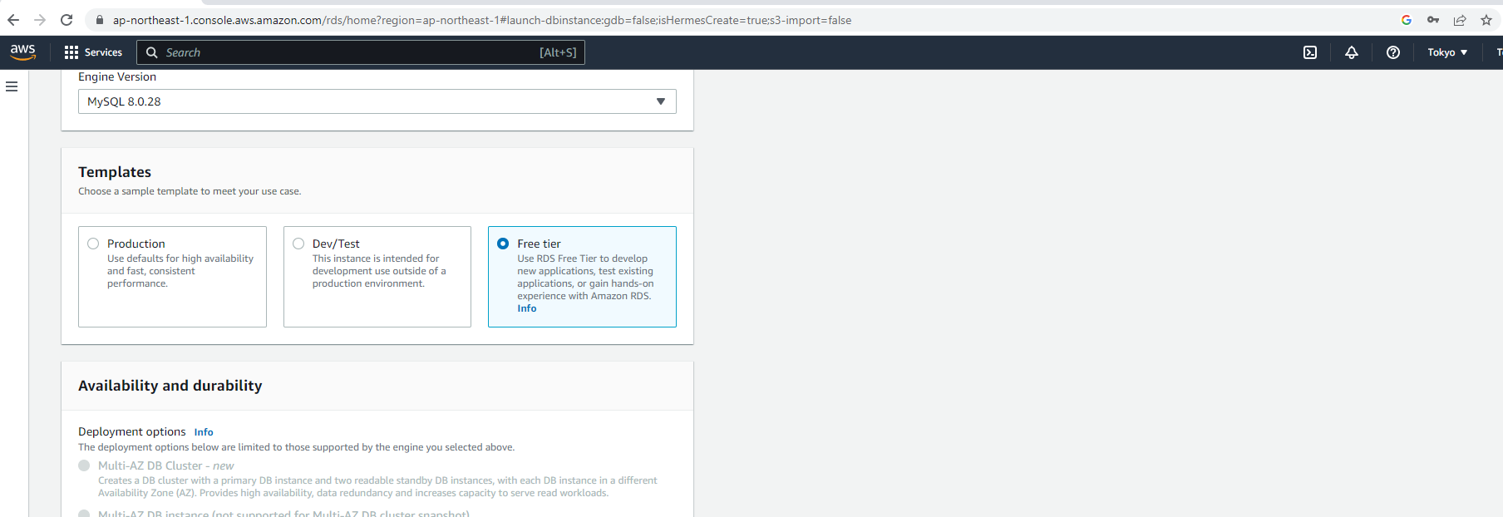

Enter wordpress in database instance identifier

Specify the master username and passwordfor database. Strong a secure password to indatabase Store the username and password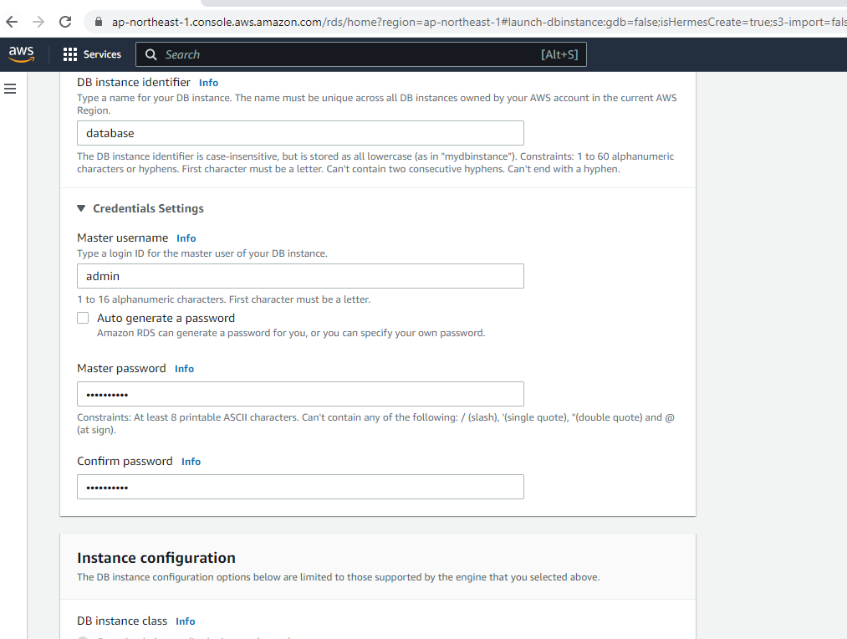

After settings username and password , selecte the key details about MYSQL deployment.

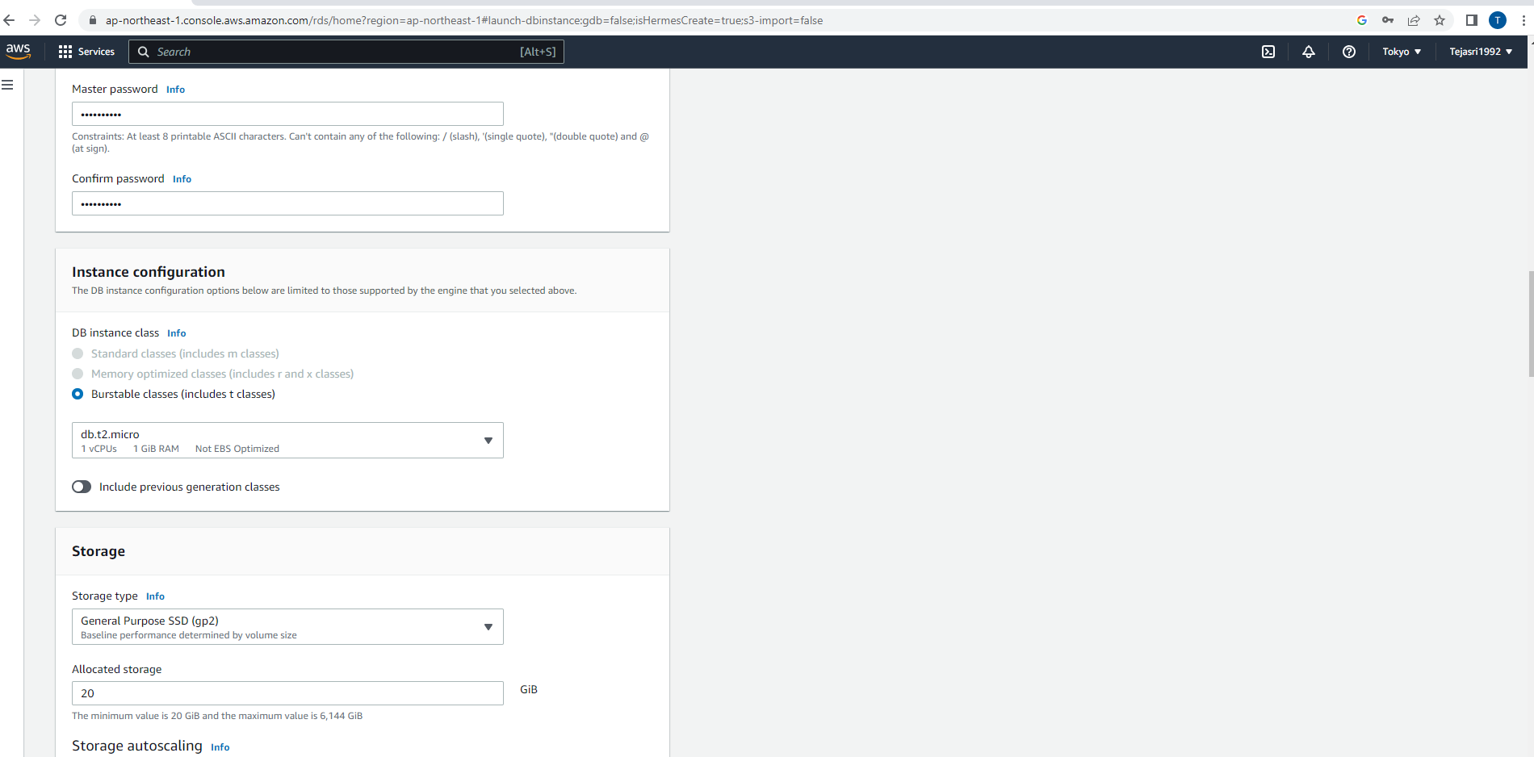

Set a larger instance class or alter the storage configuration options.

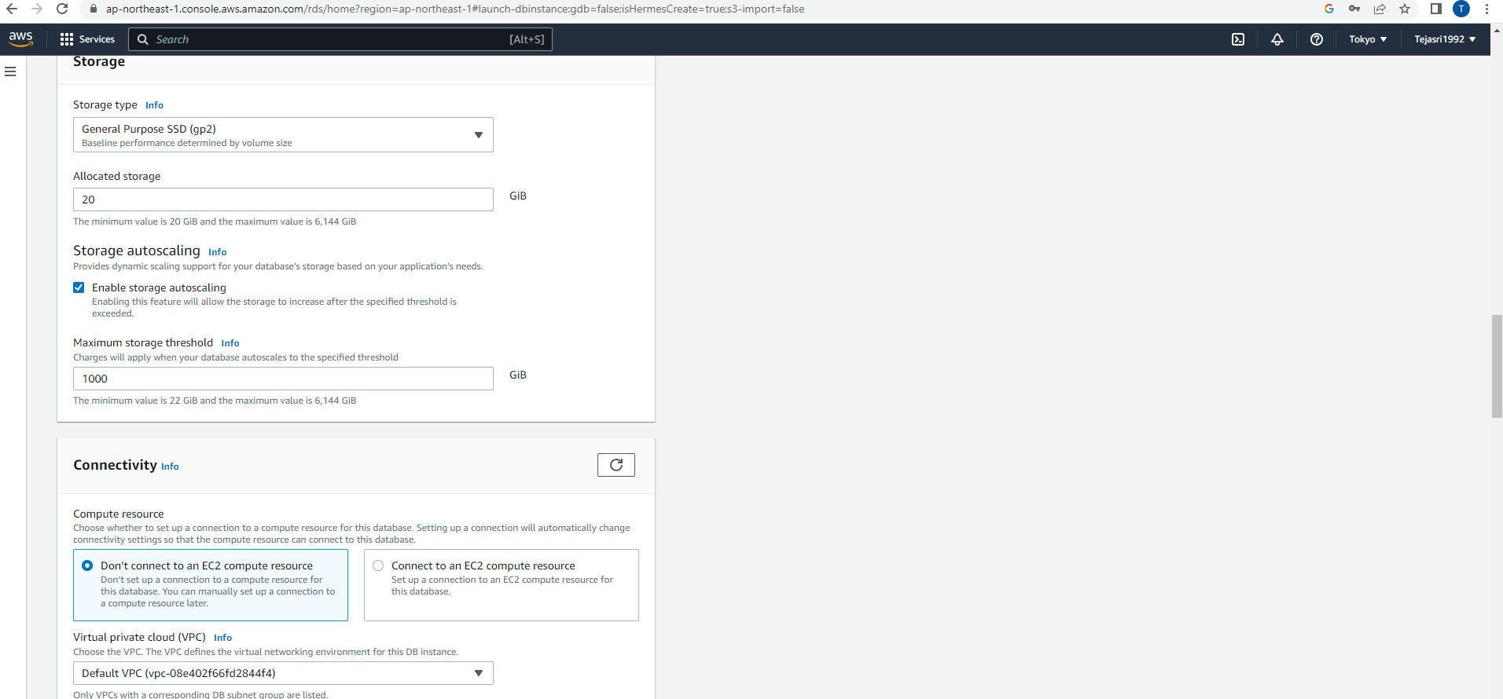

Finally RDS provides a number of additional configuration options.

The initial database name to wordpress. This ensure RDS creates the database in MYSQL instance.

The database name when connecting to database.

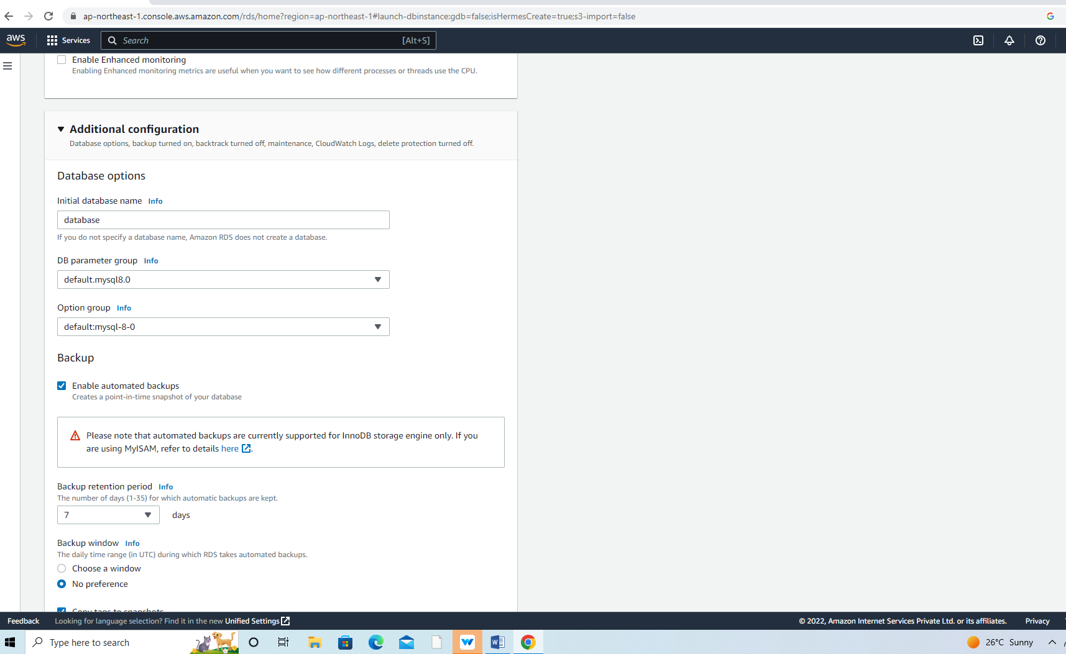

Click the create database button

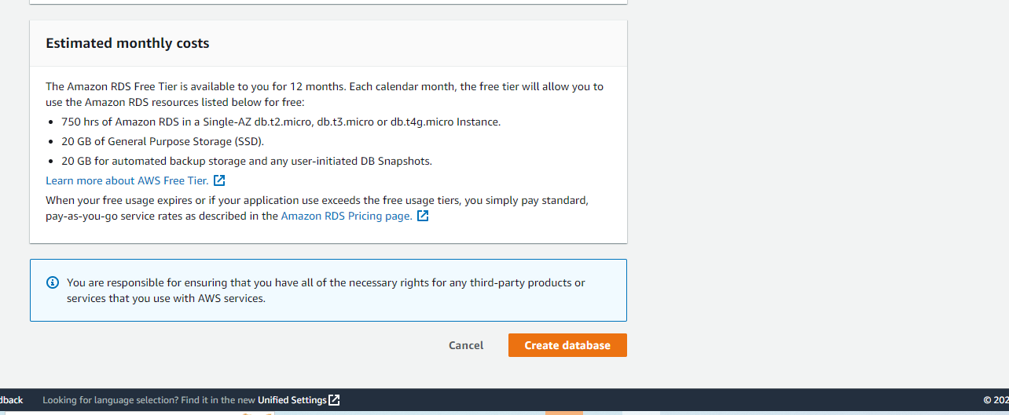

See a success notice indicating that database is creating

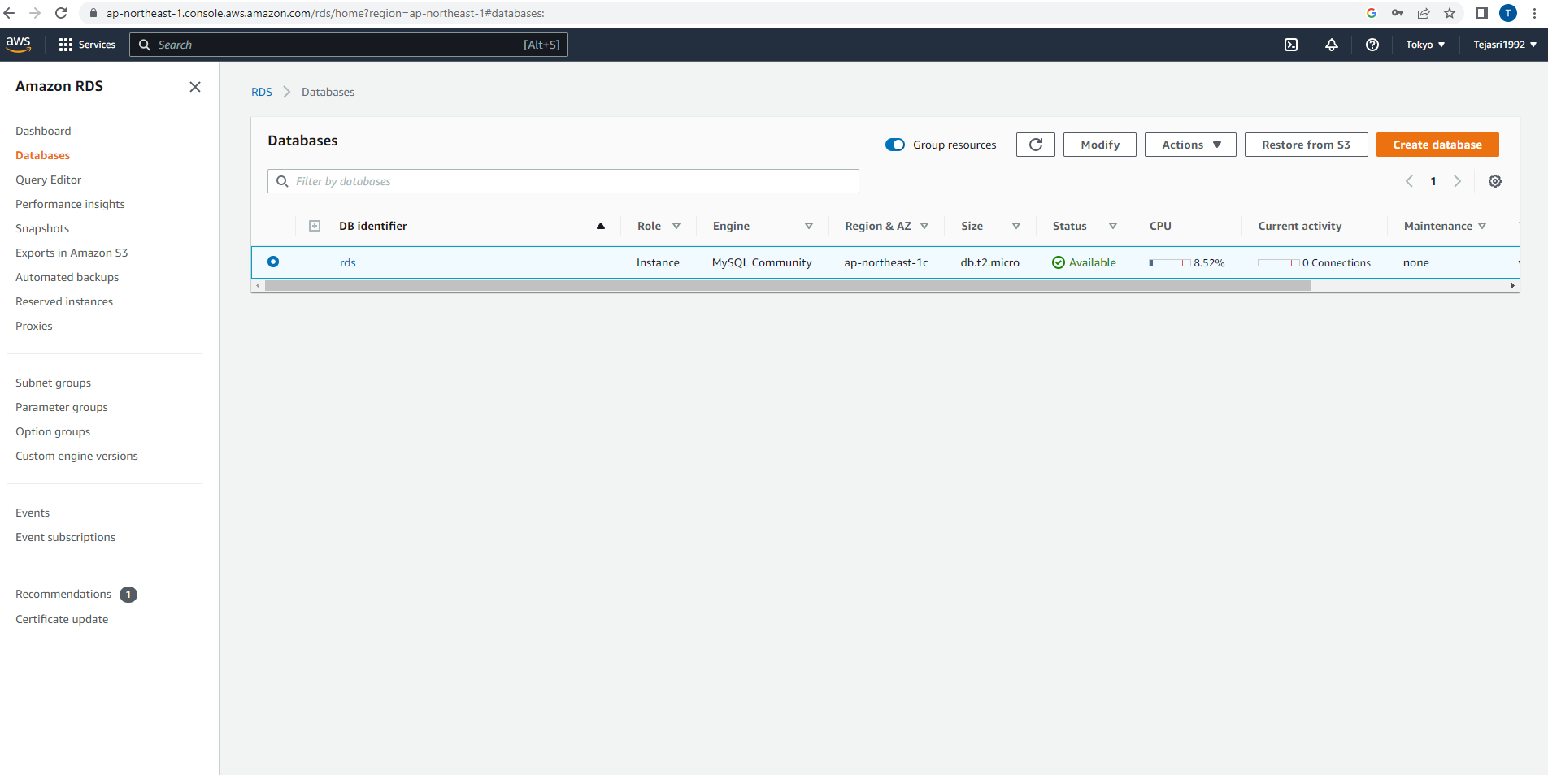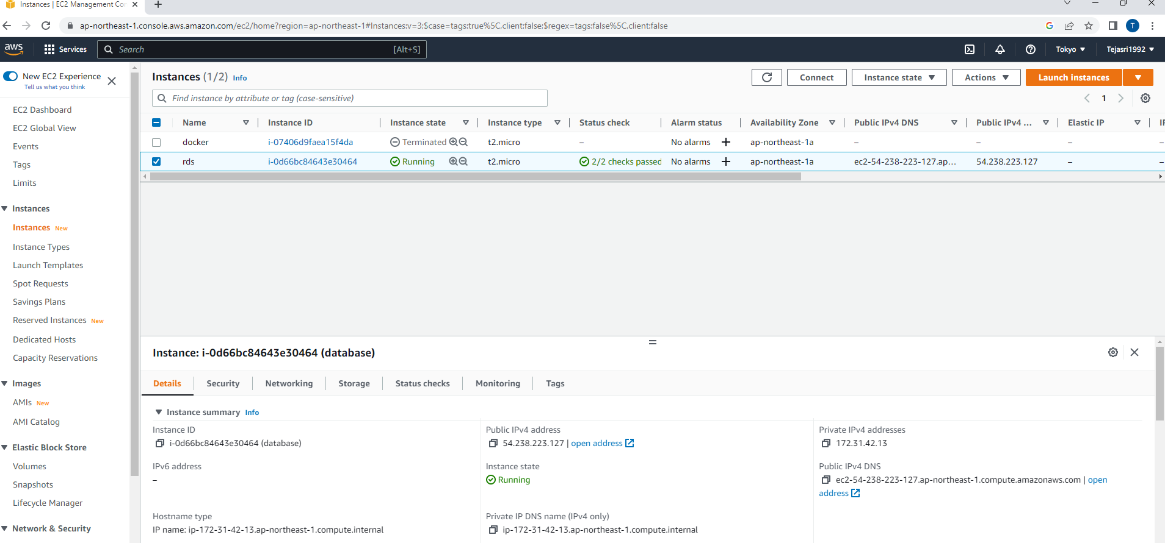

Lab -2: Creating an EC2 instance to run wordpress site.

Choosing Amazone Maching image:

Createing in ec2 instance go to Amazone EC2 in the AWS console. Click the buttion in launch instance.

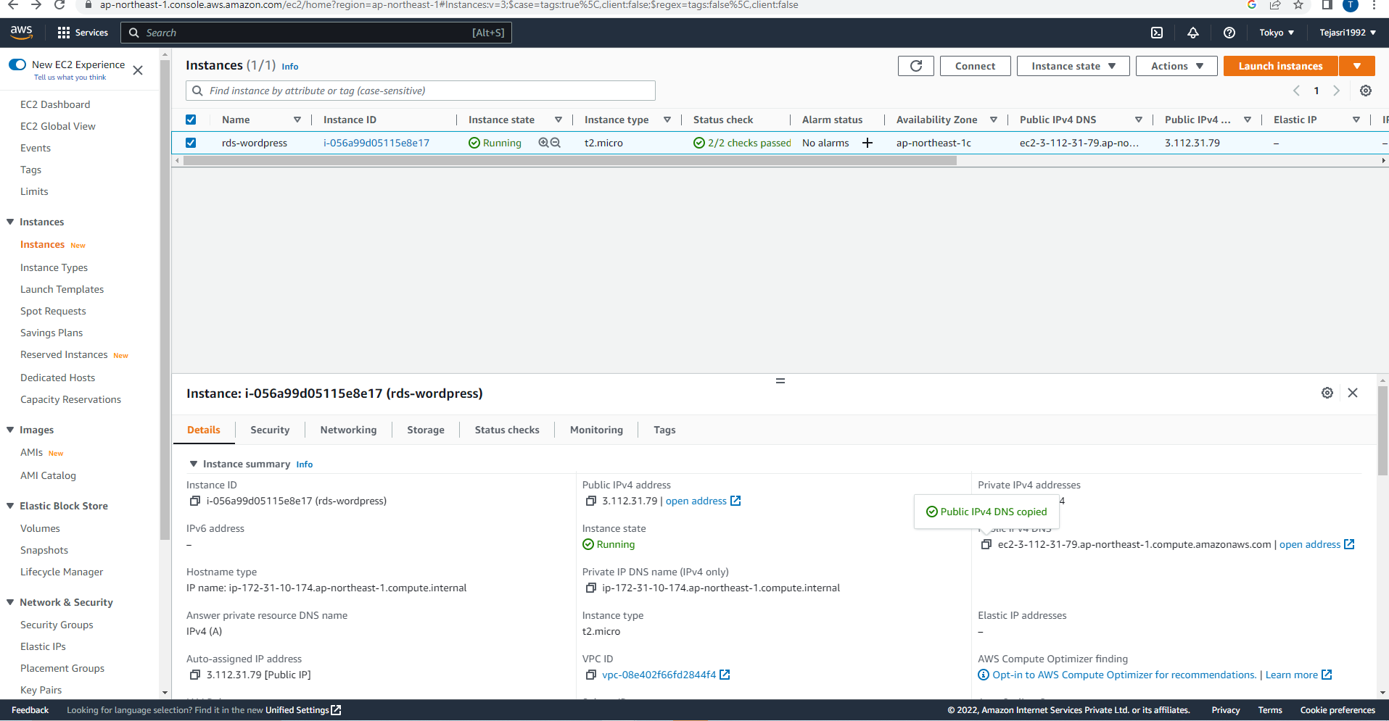

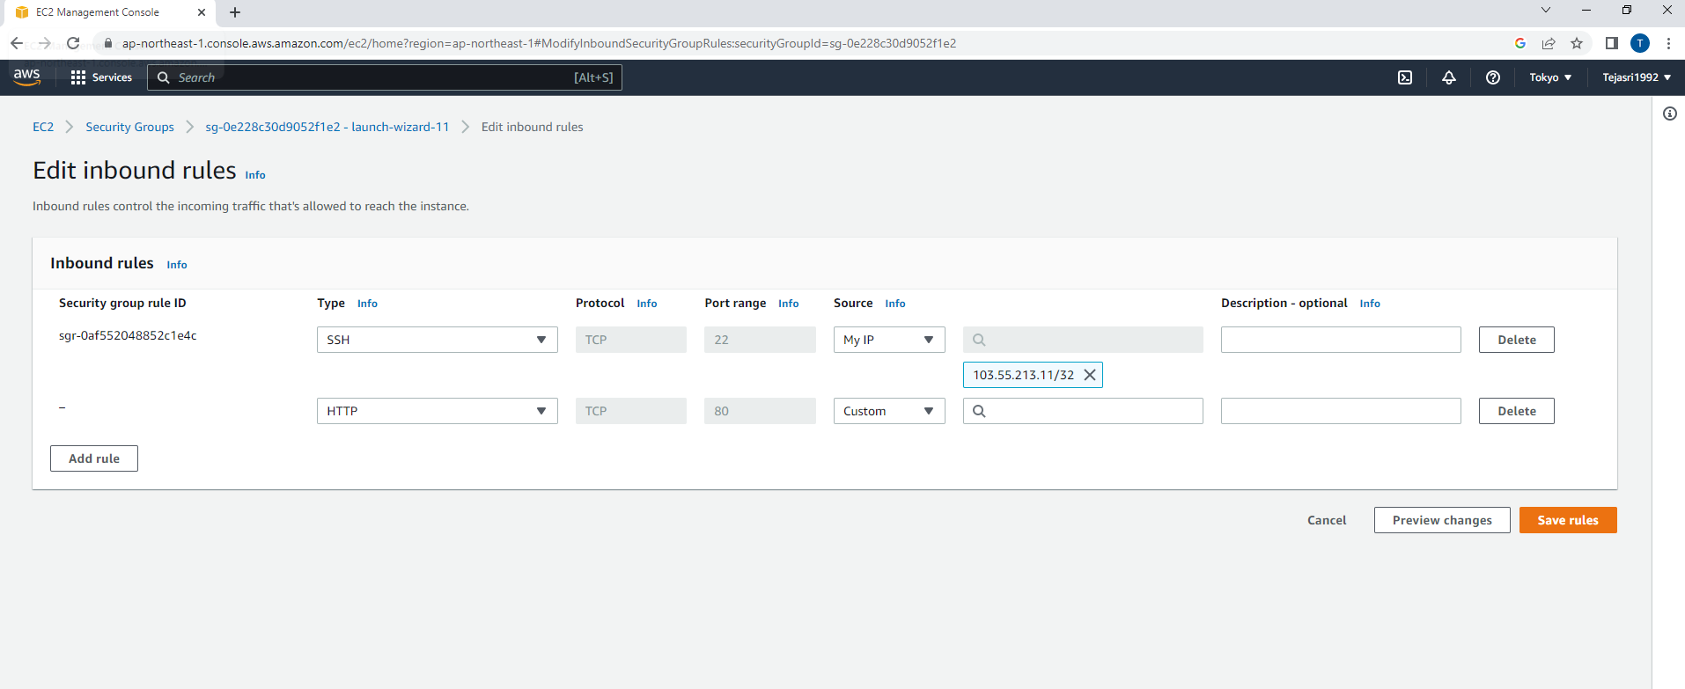

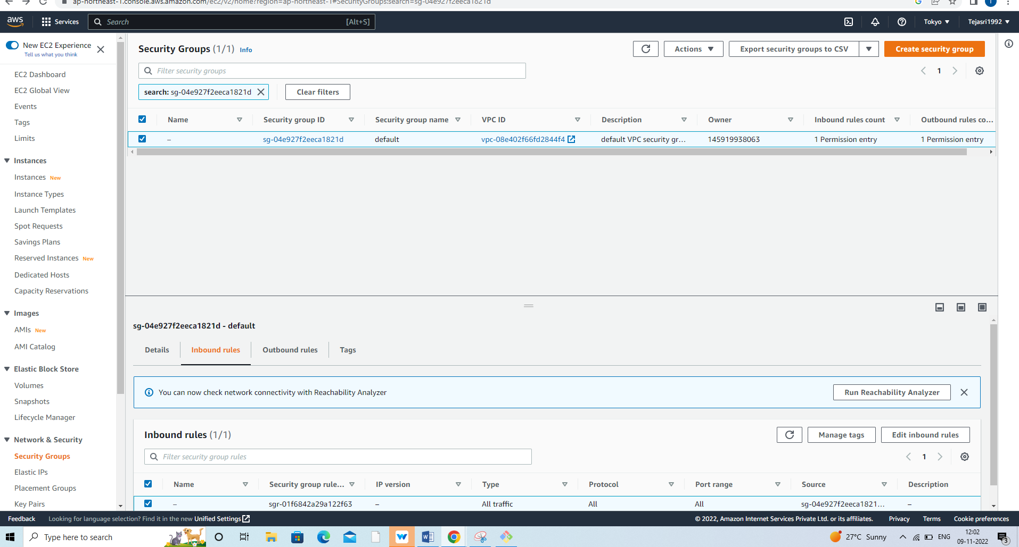

LAB -3 configuring your RDS database.

In ec2 instance to access to RDS database.

Go to in RDS database in the AWS console. Click the MYSQL database in created.

Connectivity and security tab in the display, and click the security group listed in VPC security groups.

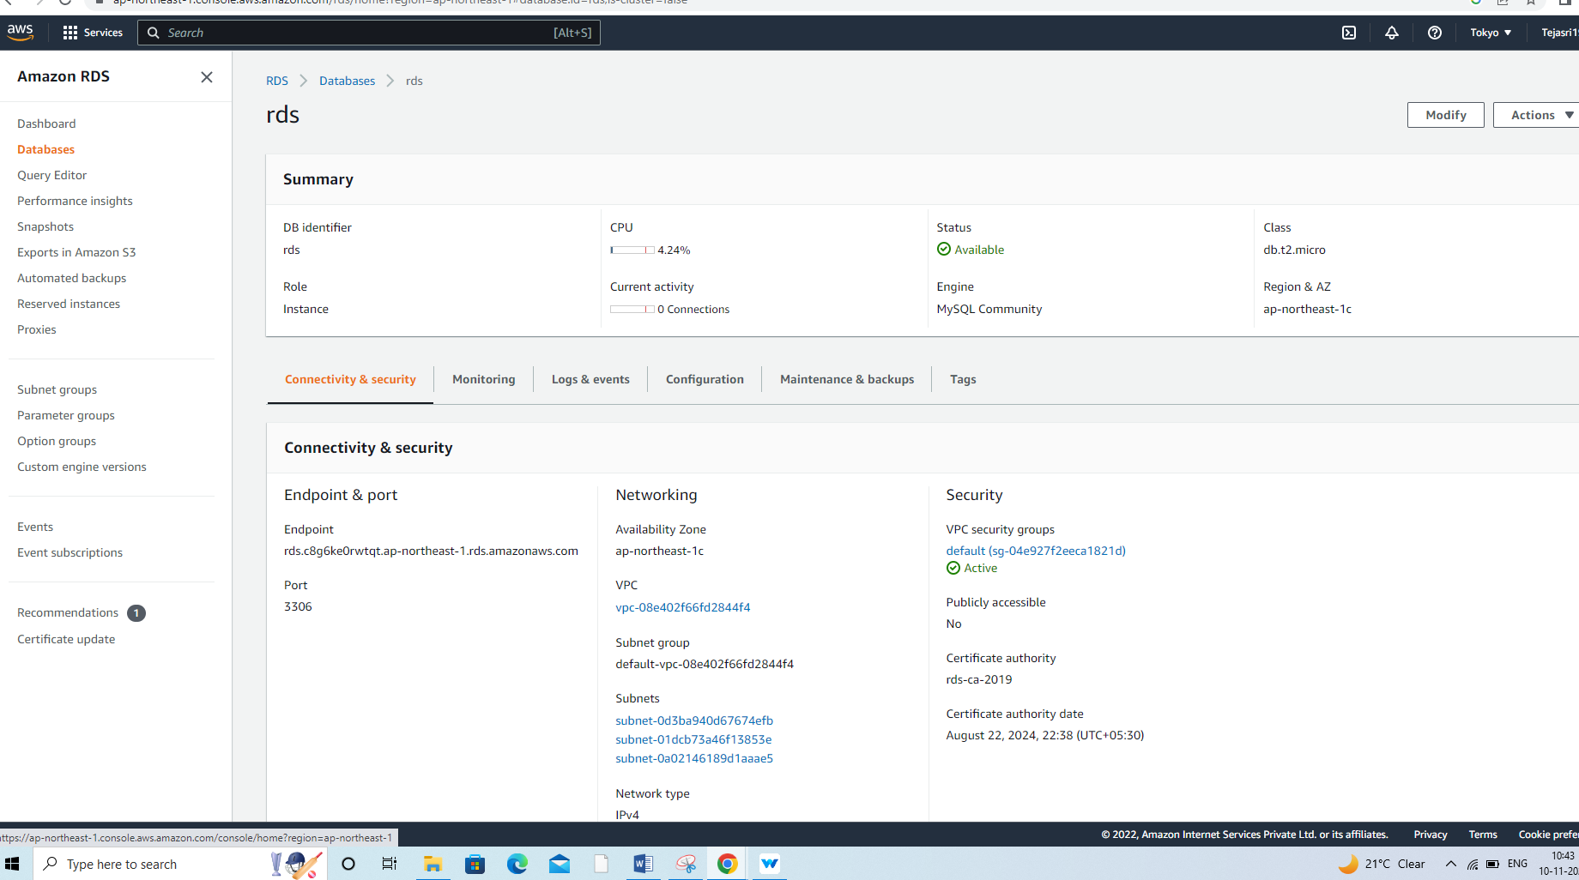

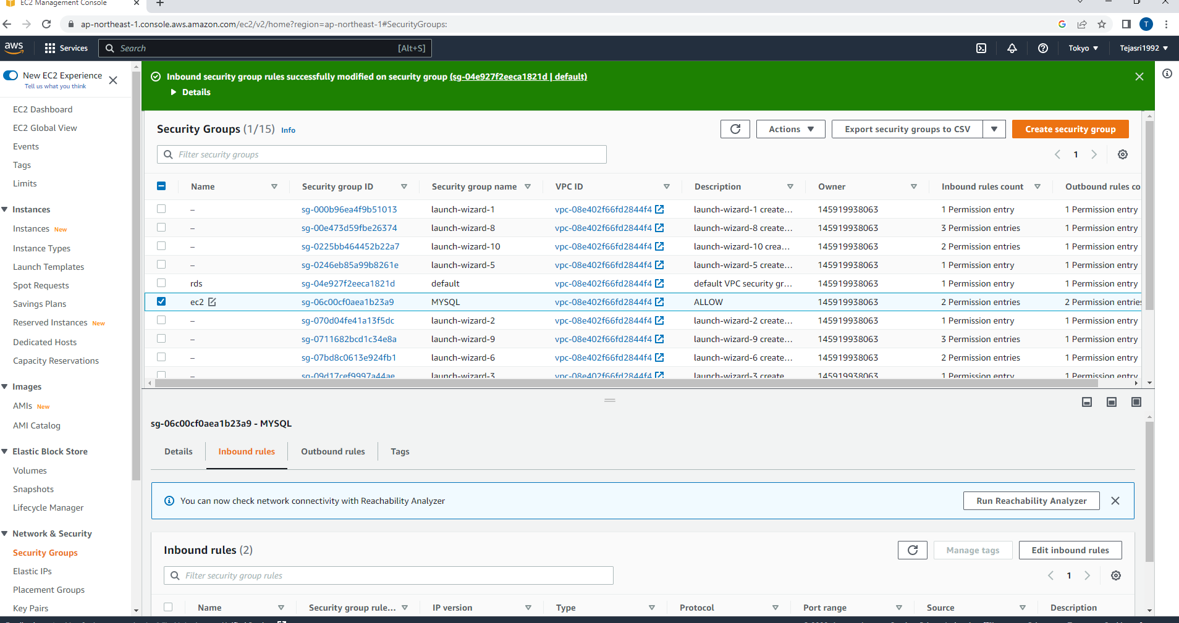

In MYSQL access to any ec2 instance with the security group configured.

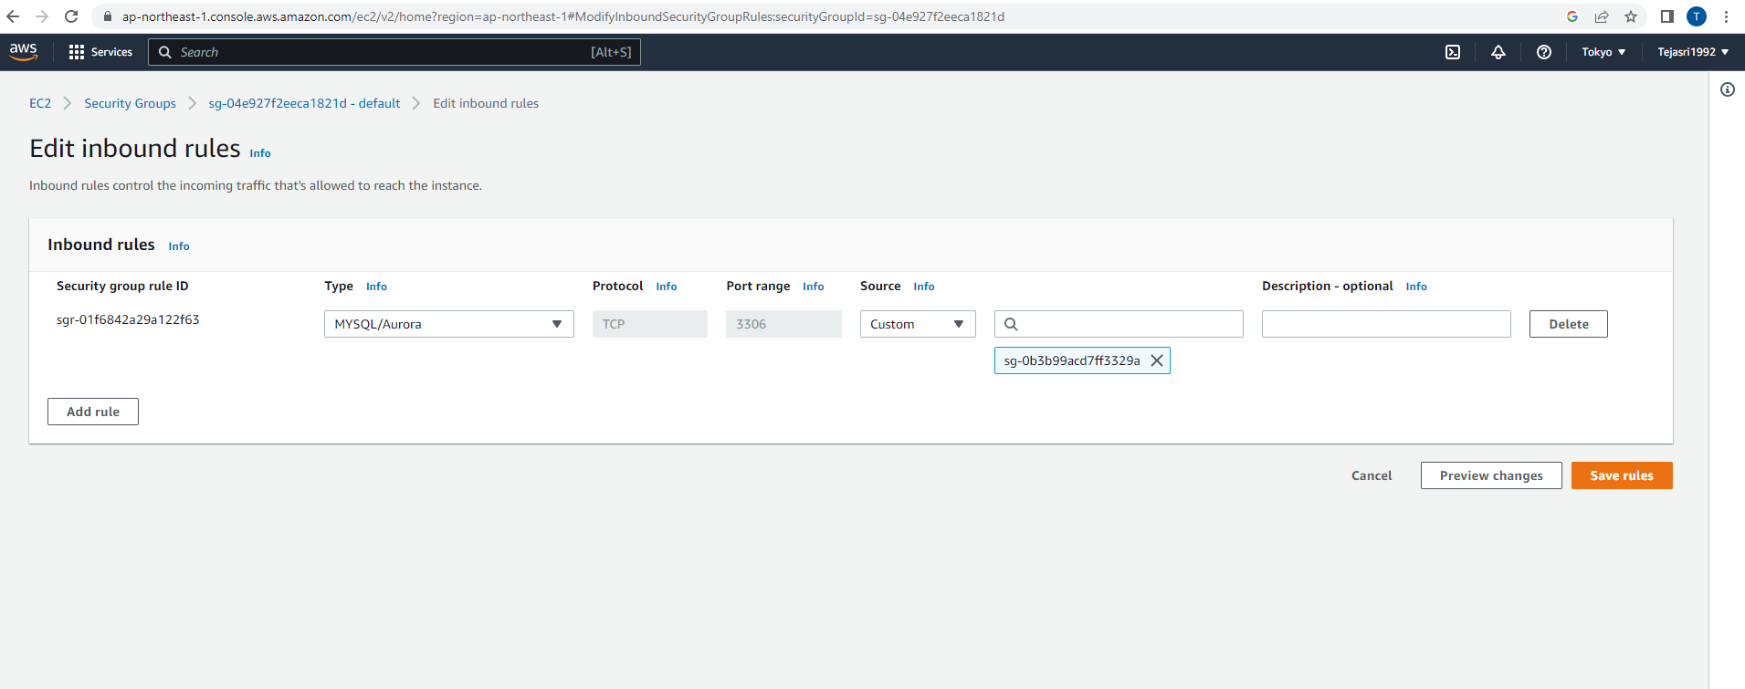

SSH in to ec2 instance.

The ec2 instances page in the aws console. See the ec2 instance created the wordpress installation.

Click the public IP address labeled IPv4 public IP in the instance description.



In linux users:

See the following in terminal to indicate that connected successfully:

Create a database user

First, run the following command in terminal to install MYSQL.

Sudo yum install –y mysql

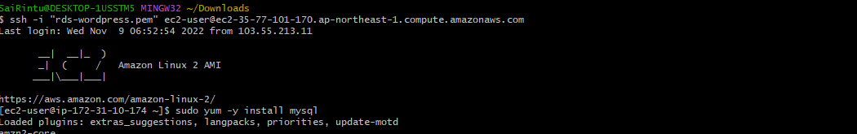

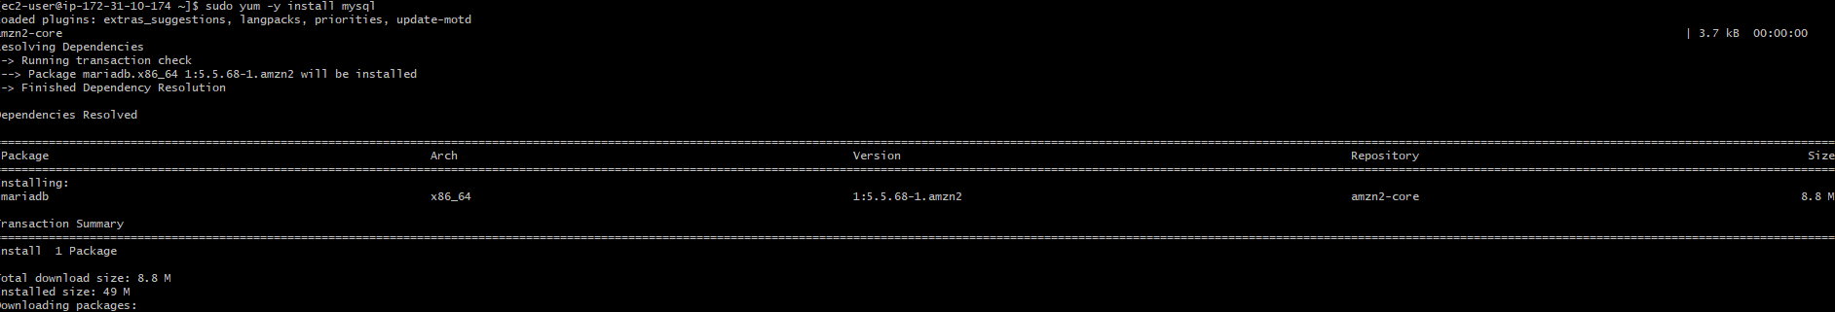

Next find the hostname in RDS database in the aws console.in the details of RDS database. The hostname will be as the endpoint in the connectivity and security section.



The following commands to mysql host. Be sure replace the hostname of RDS instance.

Export MYSQL_HOST=<rds-endpoint>

Mysql --user=<user> --password=<password> wordpress

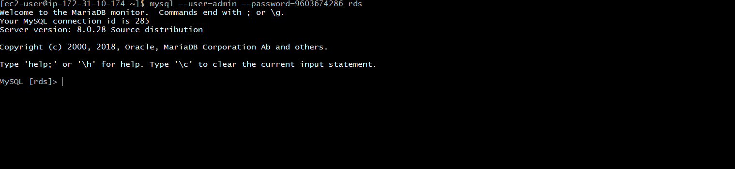

Run the following commands in terminal:

CREATE USER ‘wordpress’ IDENTIFIED BY ‘wordpress-pass’;

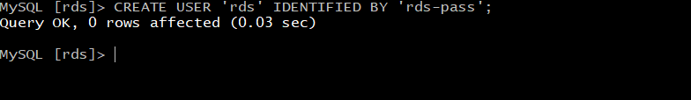

GRANT ALL PRIVILEGES ON wordpress.* TO wordpress;

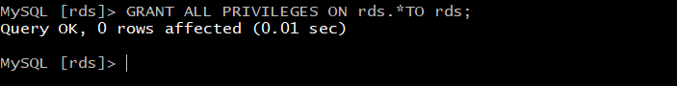

FLUSH PRIVILEGES;

EXIT

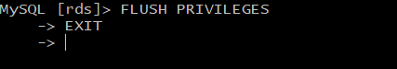

LAB- 4: configuring wordpress on EC2.

To install Apache on ec2 instance,run the following command in terminal:

Sudo yum –y install httpd

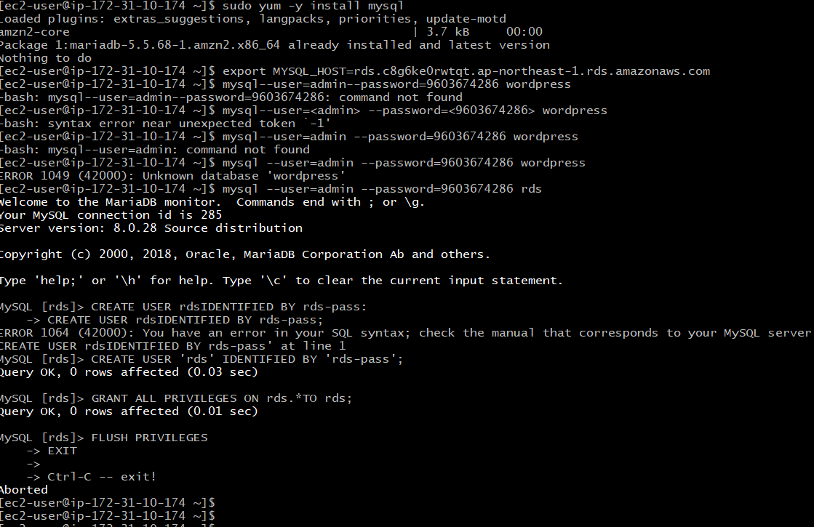

The apache web server, run the following command

Sudo service httpd start

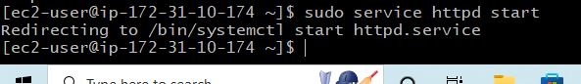

Go to the ec2 instance page. In the description below, find the public DNS (IPv4) of instance.



Enter this value into the web browser, and see an Apache test page.

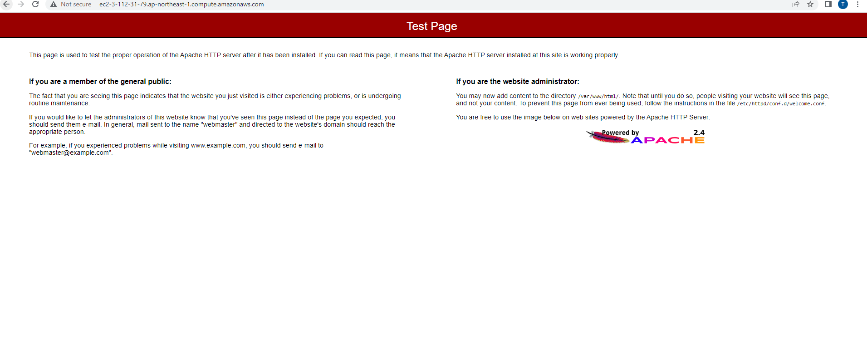

Download and configure wordpress

Running the following commands in terminal

Wget https://rds.org/latest. tar.gz

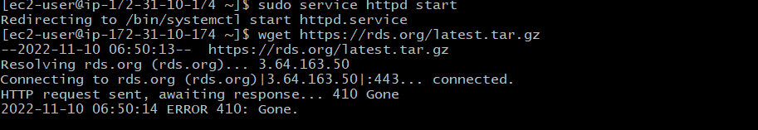

Tar –xzf latest.tar.gz



Change into the wordpress directory and create a copy of the defult config file. Using following commands.

Cd wordpress

Cp wp-config-sample.php wp-config.php



Vi wp-config. Php

Deploying wordpress site

First install the application dependencies in wordpress. Run the following command.

Sudo amazon-linux-extras install –y lamp-mariadb10.2-php7.2 php7.2

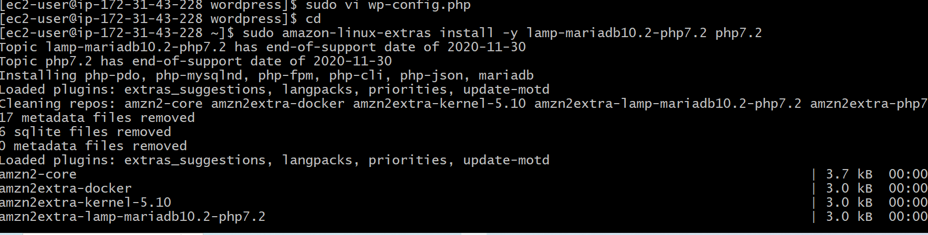

Copy your wordpress application files into the /var/www/html directory used by apache.

Sudo cp –r wordpress/* /var/www/html/

Sudo systemctl restart httpd

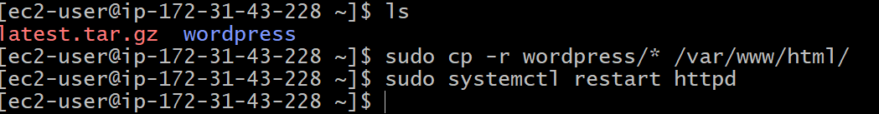

See the wordpress welcome page and the five-minute installation process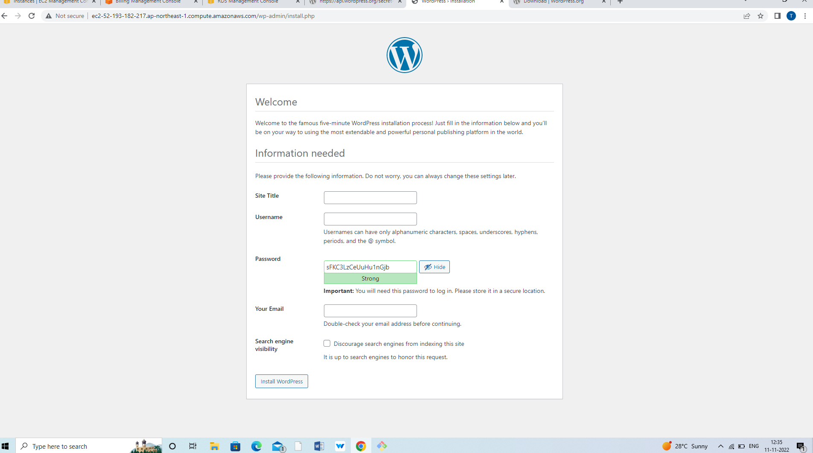

LAB-5: Explore our new website and do cleanup activity.

Remove the EC2 instancess:

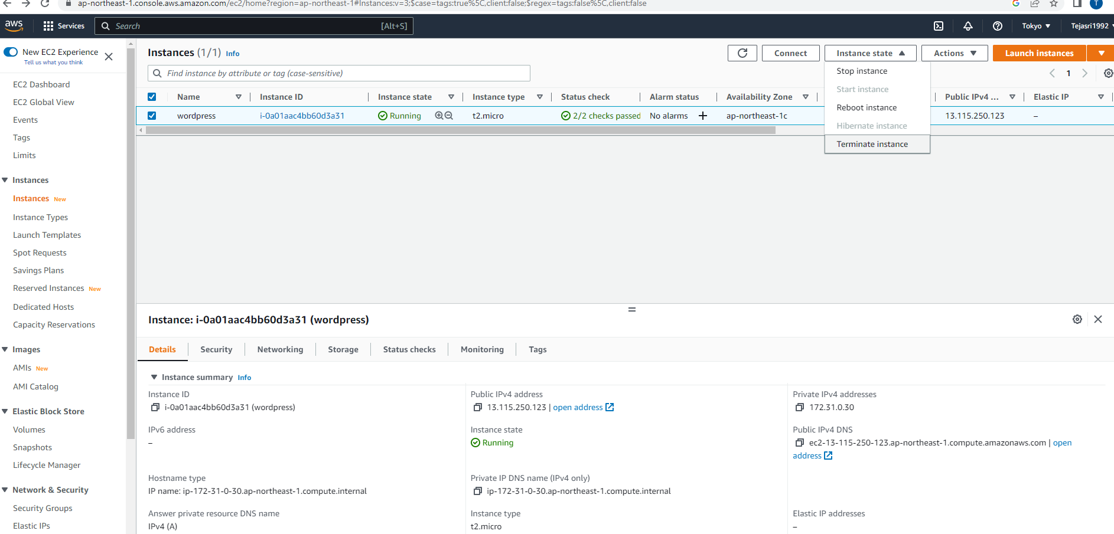

Click the terminate.

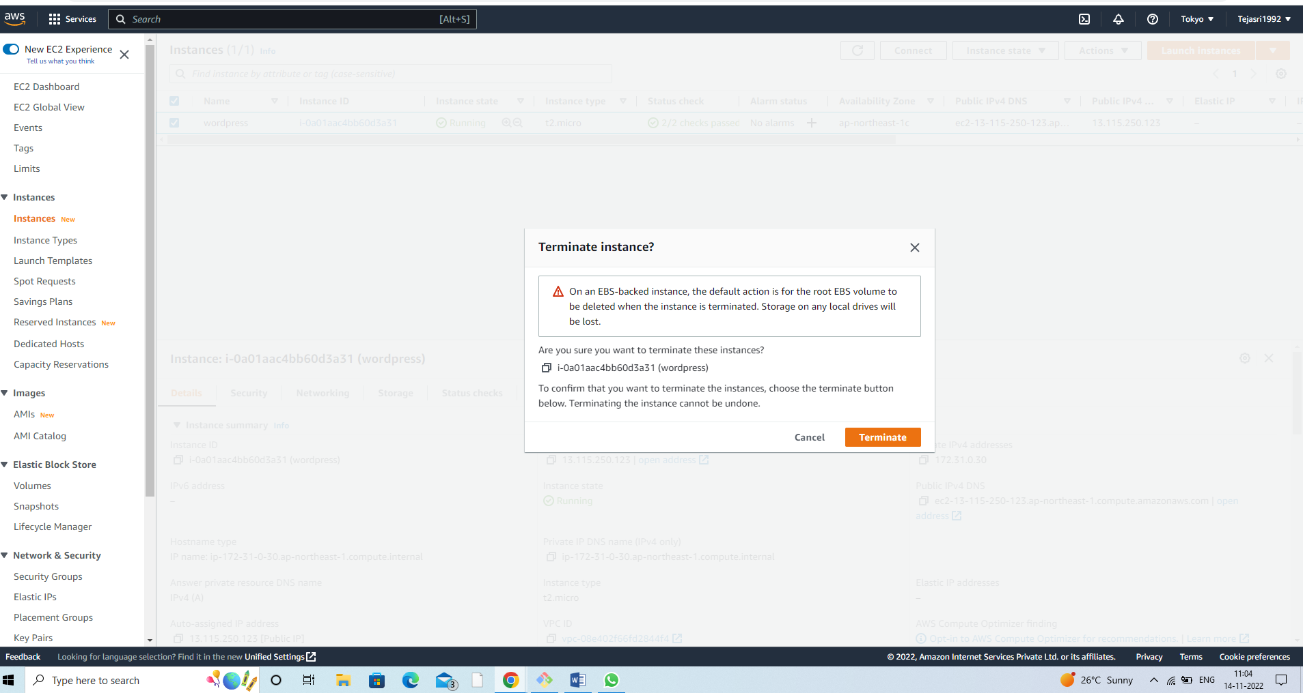

Delete the RDS instance:

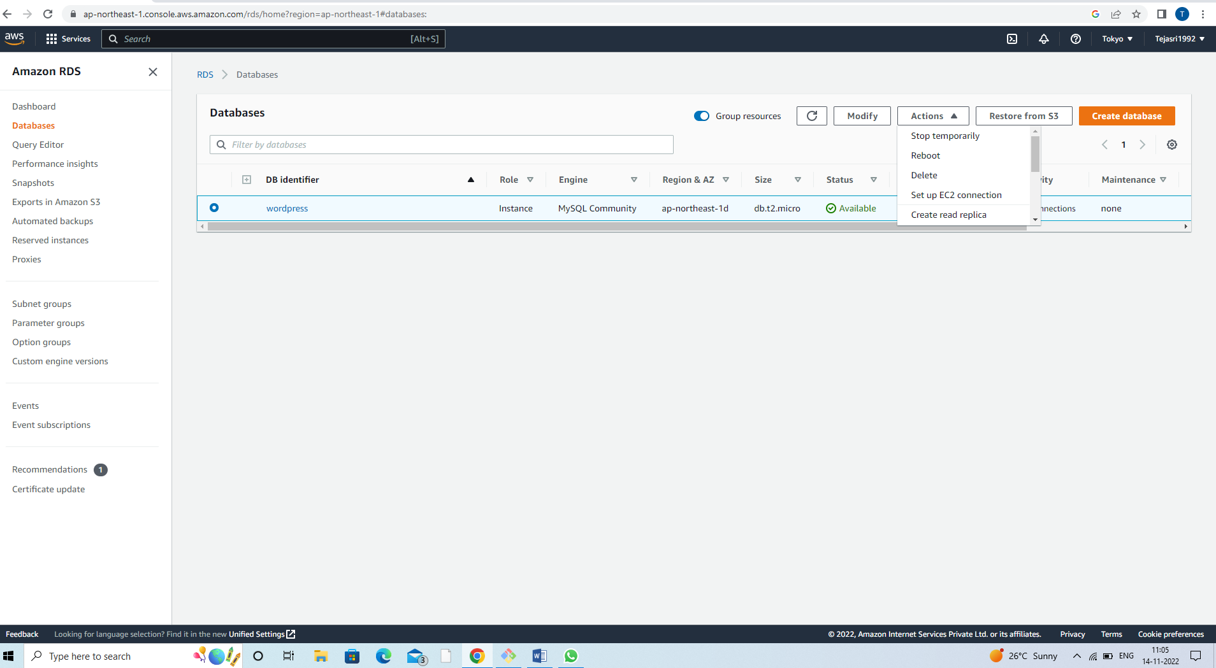

Type “delete me” into the confirmation box and delete button.

